ASSIGNMENT 5:
Module 6: Data Structures and Strings in Python
Task 1: Create a Dictionary of Student Marks

Problem Statement: Write a Python program that:
1. Creates a dictionary where student names are keys and their marks are values.
2. Asks the user to input a student's name.
3. Retrieves and displays the corresponding marks.
4. If the student’s name is not found, display an appropriate message.
Expected Output:
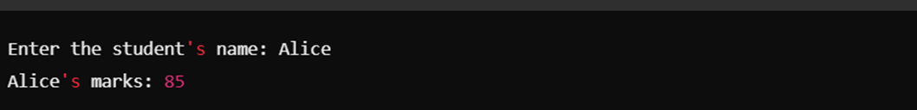
If the student does not exist in the dictionary:
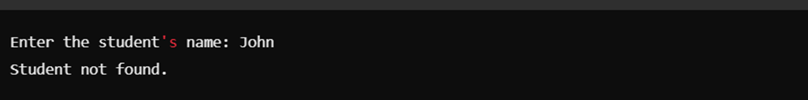
Task 2: Demonstrate List Slicing
Problem Statement: Write a Python program that:
1. Creates a list of numbers from 1 to 10.
2. Extracts the first five elements from the list.
3. Reverses these extracted elements.
4. Prints both the extracted list and the reversed list

Expected Output:
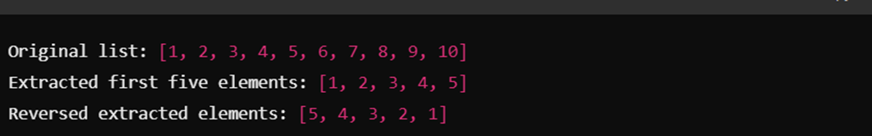
Submission Instructions:
- Create a GitHub repository and upload your Python scripts (.py files).
- Ensure the repository includes a README.md file that describes the functionality of your programs.
- Add both Task 1 and Task 2 scripts in the same repository.
- Submit the link to your GitHub repository once uploaded.

Reference:
Follow the Python course - Module 6: Data Structures and Strings for additional guidelines and examples.
Note: Please test your project thoroughly and check all the validations and error handling prior to ensure it works as expected before submission.
You can always connect to the mentor using the chat support option for any doubts or queries.

